**GIT Department of Computer Engineering**

**CSE 222/505 - Spring 2022**

**Homework # Report**

**Student Name: Muhammed Alperen Karaçete**

**Student Number: 171044052**

1. **SYSTEM REQUIREMENTS**
2. **USE CASE AND CLASS DIAGRAMS**

USE CASE DİAGRAM: CLASS DİAGRAM:

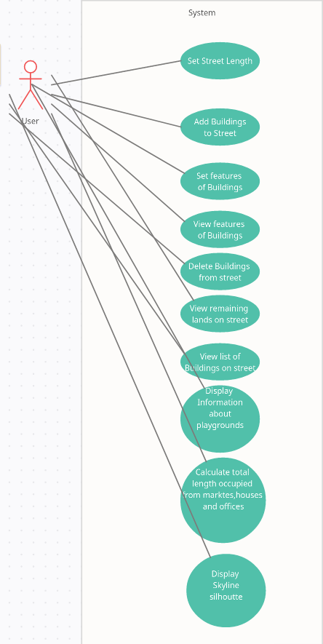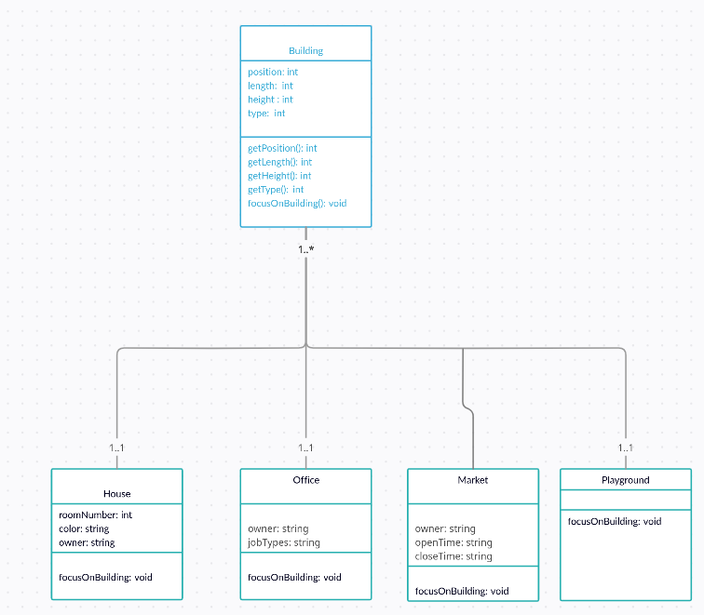

1. **PROBLEM SOLUTION APPROACH**

Write your problem solution approach. To solve a problem, you should define the problem, divide it into sub-problems, create a plan of steps, try if your approach works, etc. You can find useful articles on problem solving by googling “problem solving in software engineering”.

1. **TEST CASES**



1. **RUNNING AND RESULTS**

